Important shortcuts in BioEdit
Physalia Transposable Elements Course 2018

View options
Change view mode: View > View Mode > [lots of options]
Save custom settings: View > Save Options as Default
Look at two alignment regions: View > Split Window Vertically or View > Split Window Horizontally

Import/export/copy/paste sequences:
Import fasta sequence from outside BioEdit: File > Import from Clipboard
Export fasta sequence for outside BioEdit: Edit > Copy Sequences to clipboard (Fasta Format)
Copy sequence within BioEdit: Ctrl + F8
Paste sequence within BioEdit: Ctrl + F9
Delete sequence: Ctrl + Delete
Copy only sequence titles: Shift + Ctrl + C
Copy only sequence itself: Click on first and last position while holding Shift

Select sequences:
Select specific sequences: Click on title/s (with Ctrl for multiple) or drag mouse over multiple titles
Select all sequence titles: Ctrl + A
Unselect all sequence titles: Edit > Unselect All Sequences
Select specific positions: Click on position/s (with Shift for multiple) or drag mouse over multiple positions
Select from current position until beginning of sequence: Edit > Select to Beginning
Select from current position until end of sequence: Edit > Select to End

Manual realignment modes:
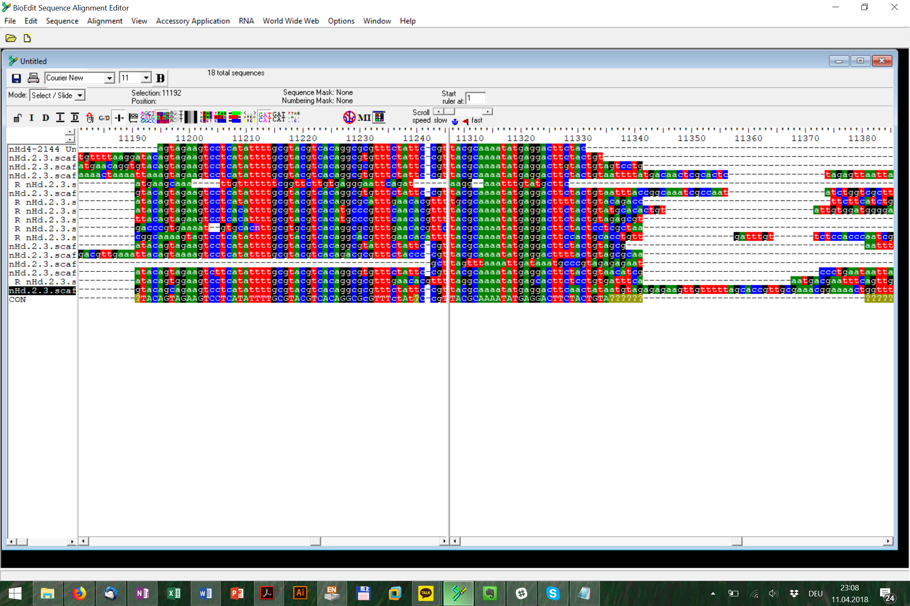: Slide positions after selected position (different effect on locked vs. unlocked gaps!)
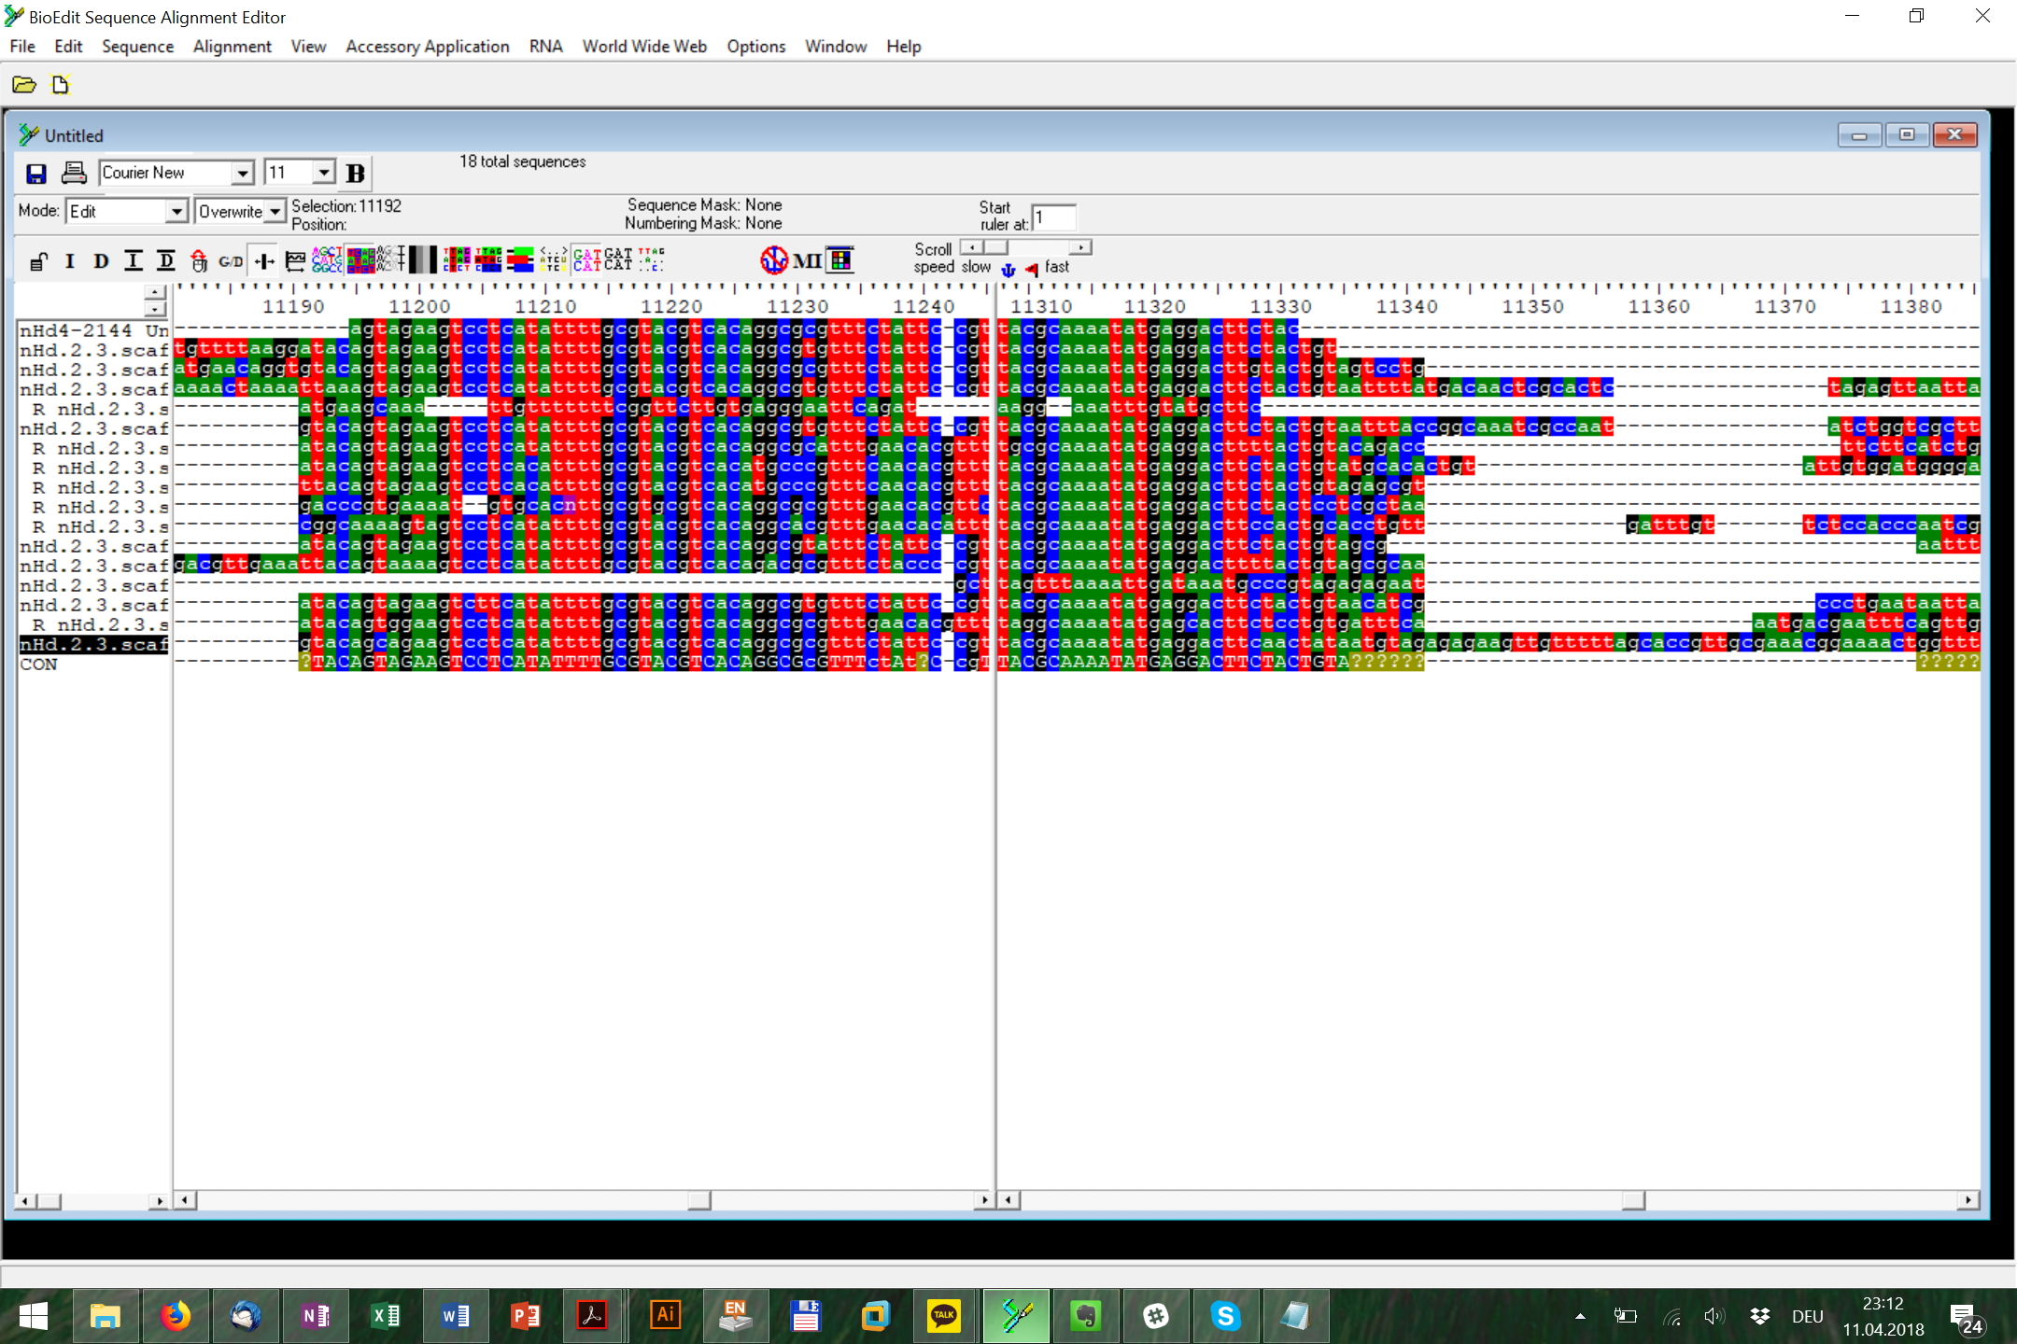: Overwrite (type or paste) or delete selected positions
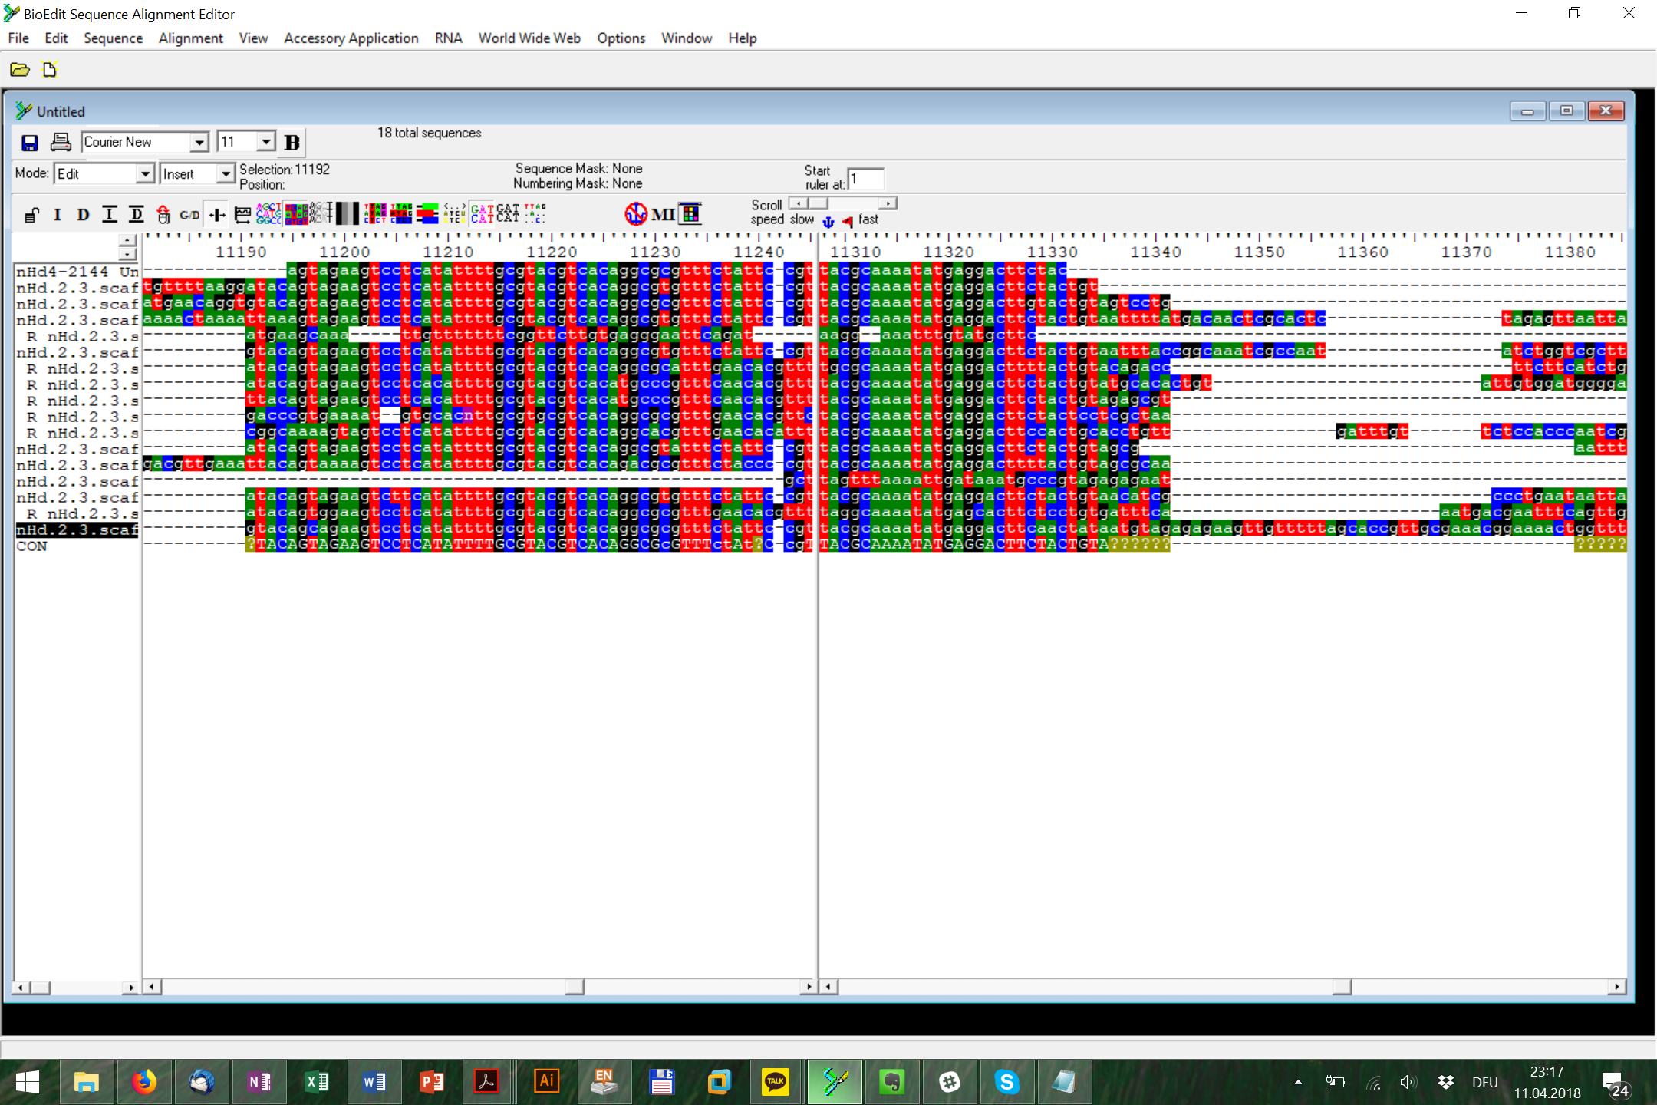: Insert (type or paste) before selected position or delete selected positions

Manipulate sequences:
Reverse complement sequence: Shift + Ctrl + R
Uppercase for positions (unselect all sequence titles!): Sequence > Manipulations > UPPERCASE
Lowercase for positions (unselect all sequence titles!): Sequence > Manipulations > lowercase
Uppercase for sequence: Sequence > Manipulations > UPPERCASE
Lowercase for sequence: Sequence > Manipulations > lowercase

Alignment gaps:
Lock gaps (“–”) in sequence: Sequence > Gaps > Lock gaps
Unlock gaps (“~”) in sequence: Shift + Ctrl + Space
Degap sequence (removes only unlocked gaps!): Ctrl + Space
Insert custom number of unlocked gaps (“~”) at position: Sequence > Gaps > Insert multiple gaps

Search for patterns:
Find pattern in sequence: Ctrl + F
Find/replace pattern in sequence: Edit > Search > Find / Replace
Find pattern in title: Edit > Search > Find in Titles
Find/replace pattern in title: Edit > Search > Find / Replace in Titles

